**Materials List for Evergreen Academy Elementary School Students 2018-2019**

Please send the following items with your child on September 4th. These items were selected by the teachers and staff in order to support your child’s learning and educational experiences at each grade level. If you ordered your supply pack through EPI, it will be in the classroom for you. Thank you for your support and for helping us to start off the year successfully!

* Lunch and a healthy snack must be brought to school each day.
* On PE days, your child will need to wear appropriate footwear for physical activity.
* **To avoid lost items, please label your child’s bag/backpack, coats, and uniforms.**

**Kindergarten**

PLEASE LABEL

* 1 school bag/backpack, regular sized, no wheels or hard frame (must fit in cubby and hold a folder)

DO NOT LABEL (these items will be shared)

* 1 blue pocket only folder
* 1 red pocket only folder
* 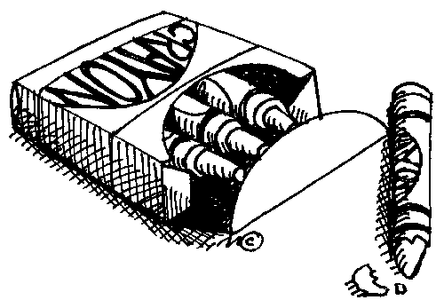1 yellow pocket only folder
* 1 green pocket only folder
* 1 orange pocket with 3 prong folder
* 2 pink bevel erasers (latex free)
* 24 Ticonderoga pre-sharpened #2 pencils (latex free)
* 1 box (8 ct) Crayola Washable Thick Classic Markers
* 1 box (48 ct) Crayola Crayons
* 2 (8 color) Crayola Washable Watercolors
* 2 boxes (12 ct) 7” Crayola Pre-sharpened Colored Pencils
* 12 Elmer’s white glue sticks (large size, .77 oz. / 22 gram)
* 1 (3”) White 3-Ring Binder with Clear Front Pocket

**ADDITIONALLY**

We are requesting that each student bring a set of headphones to keep at school for his/her personal use. These are not included in our EPI supply orders to ensure each student’s comfort.**Materials List for Evergreen Academy Elementary School Students 2018-2019**

Please send the following items with your child on September 4th. These items were selected by the teachers and staff in order to support your child’s learning and educational experiences at each grade level. If you ordered your supply pack through EPI, it will be in the classroom for you. Thank you for your support and for helping us to start off the year successfully!

* Lunch and a healthy snack must be brought to school each day.
* On PE days, your child will need to wear appropriate footwear for physical activity.
* **To avoid lost items, please label your child’s bag/backpack, coats, and uniforms.**

**First Grade**

PLEASE LABEL

* 1 school bag/backpack
* 1 plastic school box (8 ½”x 5 ¾” x 2 ½”)



DO NOT LABEL

* 1 blue plastic pocket folder
* 1 red plastic pocket folder
* 1 yellow plastic pocket folder
* 1 (8 ct) Crayola Washable Thick Classic Markers
* 1 (8 ct) Crayola Washable Thin Classic Markers
* 1 (48 ct) Crayola Crayons
* 1 (12 ct) 7” Crayola Pre-sharpened Colored Pencils
* 4 pink bevel eraser (latex free)
* 24 pencil cap erasers (latex free)
* 18 Elmer’s small (6 gram) glue sticks
* 24 Ticonderoga pre-sharpened #2 pencils (latex free)
* 1 (100 ct) Marble Composition Book with space for picture
* 2 Black Flair Medium Felt Tip Pens
* 1 pair kid-friendly round tip scissors
* 1 (3”) White 3-Ring Binder with Clear Front Pocket

**ADDITIONALLY**

We are requesting that each student bring a set of headphones to keep at school for his/her personal use. These are not included in our EPI supply orders to ensure each student’s comfort.

**Materials List for Evergreen Academy Elementary School Students 2018-2019**

Please send the following items with your child on September 4th. These items were selected by the teachers and staff in order to support your child’s learning and educational experiences at each grade level. If you ordered your supply pack through EPI, it will be in the classroom for you. Thank you for your support and for helping us to start off the year successfully!

* Lunch and a healthy snack must be brought to school each day.
* On PE days, your child will need to appropriate footwear for physical activity.
* **To avoid lost items, please label your child’s bag/backpack, coats, and uniforms.**

**Second Grade**

PLEASE LABEL

* 1 school bag/backpack
* 1 school supply bag 11” x 7.25” with grommets

DO NOT LABEL

* 7 pocket blue poly expanding folder (item ES50918 on EPI)
* 1 red plastic folder
* 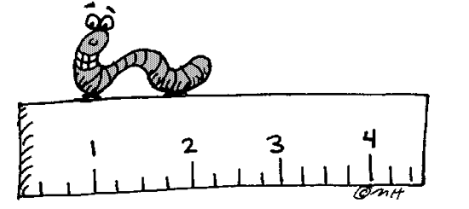1 blue plastic folder
* 1 green plastic folder
* 1 yellow plastic folder
* 6 Elmer’s glue sticks (.77 oz. / 22 gram)
* 1 (8 ct) Crayola Washable Thick Classic Markers
* 1 (8 ct) Crayola Washable Fine Tip Classic Markers
* 1 (48 ct) Crayola Crayons
* 1 (12 ct) 7” Crayola Pre-sharpened Colored Pencils
* 36 Ticonderoga #2 pencils (latex free)
* 12 pencil cap erasers (latex free)
* 2 Papermate Black Felt Tip Pens (item PMBLACK on EPI)
* 1 Three Subject wide rule Spiral 8.5 x 10.5 Notebook, 120 page count
* 3 Wide Rule Wireless Black Marble Composition Book, 100 page count
* 1 pair kid-friendly sharp pointed scissors
* 1 pack of 3” x 3” colored Post-It Notes
* 1 (3”) White 3-Ring Binder with Clear Front Pocket

**ADDITIONALLY**

We are requesting that each student bring a set of headphones to keep at school for his/her personal use. These are not included in our EPI supply orders to ensure each student’s comfort.

**Materials List for Evergreen Academy Elementary School Students 2018-2019**

Please send the following items with your child on September 4th. These items were selected by the teachers and staff in order to support your child’s learning and educational experiences at each grade level. If you ordered your supply pack through EPI, it will be in the classroom for you. Thank you for your support and for helping us to start off the year successfully!

* Lunch and a healthy snack must be brought to school each day.
* On PE days, your child will need to appropriate footwear for physical activity.
* **To avoid lost items, please label your child’s bag/backpack, coats, and uniforms.**

**Third Grade**

PLEASE LABEL

* 1 school bag/backpack
* 5 assorted color pocket only folders
* 48 pre-sharpened Ticonderoga #2 pencils (latex free)
* 1 (12 ct) 7” Crayola Pre-sharpened Colored Pencils
* 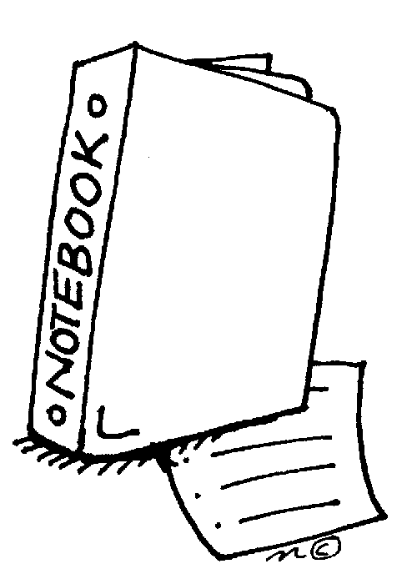1 (8 ct) Crayola Washable Thick Classic Markers
* 1 (8 ct) Crayola Washable Thin Classic Markers
* 1 (24 ct) Crayola Crayons
* Pencil Pouch or Container
* 1 pair kid-friendly sharp pointed scissors

DO NOT LABEL

* 1 (1”) white view vinyl binder
* 3 (100 ct) Black Marble Composition Book
* 8 pink bevel erasers (latex free)
* 4 Sharpie accent pen style highlighter fluorescent yellow
* 2 (200 ct) wide rule filler paper
* 2 (100 ct) 3”x5” ruled index cards
* 6 Elmer’s glue sticks (.77 oz / 22 gram)
* 4 Sharpie Black Fine Permanent Marker
* 4 Sharpie Black Ultra-Fine
* 4 Expo thin white board markers
* 1 (3”) White 3-Ring Binder with Clear Front Pocket
* 1 pack of 3” x 3” colored Post-It Notes

**ADDITIONALLY**

We are requesting that each student bring a set of headphones to keep at school for his/her personal use. These are not included in our EPI supply orders to ensure each student’s comfort.

**Materials List for Evergreen Academy Elementary School Students 2018-2019**

Please send the following items with your child on September 4th. These items were selected by the teachers and staff in order to support your child’s learning and educational experiences at each grade level. If you ordered your supply pack through EPI, it will be in the classroom for you. Thank you for your support and for helping us to start off the year successfully!

* Lunch and a healthy snack must be brought to school each day.
* On PE days, your child will need to appropriate footwear for physical activity.
* **To avoid lost items, please label your child’s bag/backpack, coats, and uniforms.**

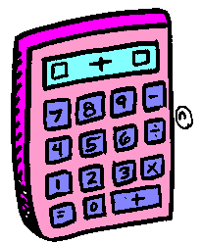**Fourth Grade**

PLEASE LABEL

* 1 school bag/backpack

DO NOT LABEL

* 1 (24 ct) 7” Crayola Pre-sharpened Colored Pencils
* 1 (24 ct) Crayola Crayons
* 1 (8 ct) Crayola Markers
* 5 (70 ct) wide rule spiral notebooks (one each red, yellow, blue, green, black)
* 1 (100 ct) wide ruled black marble composition books
* 3 packs Ticonderoga pre-sharpened #2 pencils (latex free)
* 12 pencil cap erasers (latex free)
* 3 pink bevel erasers (latex free)
* 2 style highlighters yellow
* 1 Sharpie black ultra- fine point marker
* 1 Sharpie black fine marker
* 4 Elmer’s glue stick (.77 oz / 22 gram)
* 6 assorted pocket only folders (one each red, yellow, blue, green, black, choice)
* 1 (1”) Vinyl 3-Ring Binder with Clear Front Pocket
* 1 (3”) White 3-Ring Binder with Clear Front Pocket
* 1 pack of 3” x 3” colored Post-It Notes
* 1 pair kid-friendly sharp pointed scissors

**ADDITIONALLY**

We are requesting that each student bring a set of on the ear adjustable headphones to keep at school for his/her personal use. These are not included in our EPI supply orders to ensure each student’s comfort.

**Materials List for Evergreen Academy Elementary School Students 2018-2019**

Please send the following items with your child on September 4th. These items were selected by the teachers and staff in order to support your child’s learning and educational experiences at each grade level. If you ordered your supply pack through EPI, it will be in the classroom for you. Thank you for your support and for helping us to start off the year successfully!

* Lunch and a healthy snack must be brought to school each day.
* On PE days, your child will need to appropriate footwear for physical activity.
* **To avoid lost items, please label your child’s bag/backpack, coats, and uniforms.**

**Fifth Grade**

PLEASE LABEL

* 1 school bag/backpack
* 1 plastic school box (8 ½”x 5 ¾” x 2 ½”)

DO NOT LABEL

* 4 Elmer’s glue sticks (.77 oz / 22 gram)
* 2 (200 ct) wide rule filler paper
* 1 (1”) Vinyl 3-Ring Binder with Clear Front Pocket
* 1 (3”) White 3-Ring Binder with Clear Front Pocket
* 1 (24 ct) 7” Crayola Pre-sharpened Colored Pencils
* 1 (24 ct) Crayola Crayons
* 1 box (8ct) Crayola washable fine tip markers
* 5 (70 ct) wide rule spiral notebooks (one each red, yellow, blue, green, black)
* 1 (100ct) black marble composition book, wide rule
* 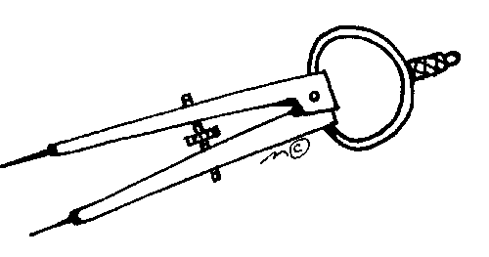6 assorted pocket only folders (one each red, yellow, blue, green, black, choice)
* 4 pink Bevel erasers (latex free)
* 72 Ticonderoga pre-sharpened #2 pencils (latex free)
* 2 style highlighters yellow
* 1 Sharpie black ultra-fine point marker
* 1 Sharpie black fine marker
* 1 pack of 3” x 3” colored Post-It Notes
* 1 pair kid-friendly sharp pointed scissors

**ADDITIONALLY**

We are requesting that each student bring a set of headphones to keep at school for his/her personal use. These are not included in our EPI supply orders to ensure each student’s comfort.