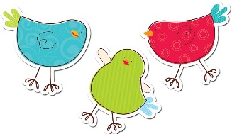
Mrs. Allen’s Kindergarten Schedule
2018-2019
 | Monday | Tuesday | Wednesday | Thursday | Friday
8:30 | Launch | Number Corner & Math | Number Corner & Math | Number Corner & Math | Number Corner & Math
 | Math
9:30 | Snack | Snack | Snack | Snack | Snack
9:45 | Recess | Recess | Recess | Recess | Recess
10:00 | Literacy | Literacy | Literacy | Literacy | Literacy
11:00 | Lunch | Lunch | Lunch | Lunch | Lunch
11:30 | Recess | Recess | Recess | Recess | Recess
12:00 | Drama | Library | Foreign Language | Music | Technology
12:30 | Art | Foreign Language | PE | Art | PE
1:00 | Literacy | Literacy | Literacy | Literacy | Literacy
1:30 | Snack | Snack | Snack | Snack | Snack
1:45 | Recess | Recess | Recess | Recess | Recess
2:00 | Social Studies/ Science | Social Studies/ Science | Social Studies/ Science | Social Studies/ Science | Social Studies/ Science
3:00 3:10 | Closing & Dismissal (3:10) | Closing & Dismissal (3:10) | Closing & Dismissal (3:10) | Closing & Dismissal (3:10) | Closing & Dismissal (3:10)

