**Materials List for Evergreen Academy Elementary School Students 2019-2020**

Please send the following items with your child on September 3rd. These items were selected by the teachers and staff in order to support your child’s learning and educational experiences at each grade level. If you ordered your supply pack through EPI, it will be in the classroom for you. Thank you for your support and for helping us to start off the year successfully!

* A reusable water bottle, lunch and healthy snacks must be brought to school each day.
* On PE days, your child will need to wear appropriate footwear for physical activity.
* **To avoid lost items, please label your child’s bag/backpack, coats, water bottle and uniforms.**

**Kindergarten**

PLEASE LABEL

* 1 school bag/backpack, regular sized, no wheels or hard frame (must fit in cubby and hold a folder)
* 1 reusable water bottle

DO NOT LABEL (these items will be shared)

* 1 blue pocket only folder
* 1 red pocket only folder
* 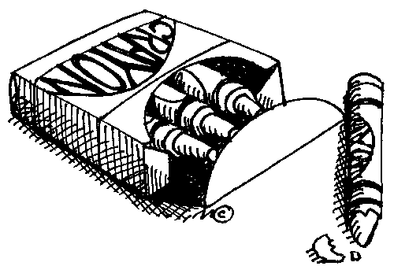1 yellow pocket with 3 prongs folder
* 1 green pocket with 3 prongs folder
* 2 pink bevel erasers (latex free)
* 24 Ticonderoga pre-sharpened #2 pencils
* 1 box (8 ct) Crayola Washable Thick Classic Markers
* 1 box (48 ct) Crayola Crayons
* 2 (8 color) Crayola Washable Watercolors
* 2 boxes (12 ct) 7” Crayola Pre-sharpened Colored Pencils
* 12 Elmer’s glue sticks (large size, .77 oz. / 22 gram)
* 1 (3”) White 3-Ring Binder with Clear Front Pocket

**ADDITIONALLY**

We are requesting that each student bring a set of headphones to keep at school for his/her personal use. These are not included in our EPI supply orders to ensure each student’s comfort.**Materials List for Evergreen Academy Elementary School Students 2019-2020**

Please send the following items with your child on September 3rd. These items were selected by the teachers and staff in order to support your child’s learning and educational experiences at each grade level. If you ordered your supply pack through EPI, it will be in the classroom for you. Thank you for your support and for helping us to start off the year successfully!

* Reusable water bottle, lunch and healthy snacks must be brought to school each day.
* On PE days, your child will need to wear appropriate footwear for physical activity.
* **To avoid lost items, please label your child’s bag/backpack, coats, water bottle and uniforms.**

**First Grade**

PLEASE LABEL

* 1 school bag/backpack
* 1 reusable water bottle
* 1 plastic school box (8 ½”x 5 ¾” x 2 ½”)



DO NOT LABEL

* 1 blue plastic pocket folder
* 1 red plastic pocket folder
* 1 yellow plastic pocket folder
* 1 green plastic pocket folder
* 2 (8 ct) Crayola Washable Thick Classic Markers
* 1 (8 ct) Crayola Washable Thin Classic Markers
* 1 (48 ct) Crayola Crayons
* 1 (12 ct) 7” Crayola pre-sharpened Colored Pencils
* 1 variety pack thin Expo dry erase markers
* 4 pink bevel eraser (latex free)
* 24 pencil cap erasers (latex free)
* 24 Elmer’s small (6 gram) glue sticks
* 24 Ticonderoga pre-sharpened #2 pencils (latex free)
* 1 (100 ct) Marble Composition Book with space for picture
* 4 Black Flair Medium Felt Tip Pens
* 1 pair kid-friendly round tip scissors
* 1 (3”) White 3-Ring Binder with Clear Front Pocket

**ADDITIONALLY**

We are requesting that each student bring a set of headphones to keep at school for his/her personal use. These are not included in our EPI supply orders to ensure each student’s comfort.

**Materials List for Evergreen Academy Elementary School Students 2019-2020**

Please send the following items with your child on September 3rd.  These items were selected by the teachers and staff in order to support your child’s learning and educational experiences at each grade level.  If you ordered your supply pack through EPI, it will be in the classroom for you. Thank you for your support and for helping us to start off the year successfully!

* Lunch and a healthy snack must be brought to school each day.
* On PE days, your child will need to appropriate footwear for physical activity.
* **To avoid lost items, please label your child’s bag/backpack, coats, and uniforms.**

**Second Grade**

PLEASE LABEL

* 1 school bag/backpack
* 1 school supply bag 11” x 7.25” with grommets OR plastic pencil box

DO NOT LABEL

* 1 red pocket folder
* 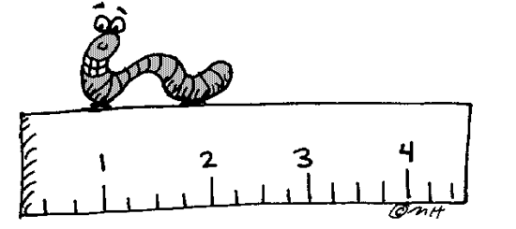1 blue pocket folder
* 1 green pocket folder
* 1 yellow pocket folder
* 12 Elmer’s glue sticks (.77 oz. / 22 gram)
* 1 (8 ct) Crayola Washable Thick Classic Markers
* 1 (8 ct) Crayola Washable Fine Tip Classic Markers
* 1 (48 ct) Crayola Crayons
* 1 (12 ct) 7” Crayola pre-sharpened Colored Pencils
* 36 Ticonderoga #2 pencils (latex free)
* 2 large pink erasers
* 12 pencil cap erasers (latex free)
* 2 Papermate Black Felt Tip Pens (item PMBLACK on EPI)
* 1 pair kid-friendly sharp pointed scissors
* 1 box of Kleenex
* 1 ruler (with both inches and centimeters)
* 1 (3”) White 3-Ring Binder with Clear Front Pocket

**ADDITIONALLY**

We are requesting that each student bring a set of headphones to keep at school for his/her personal use. These are not included in our EPI supply orders to ensure each student’s comfort.

**Materials List for Evergreen Academy Elementary School Students 2019-2020**

Please send the following items with your child on September 3rd. These items were selected by the teachers and staff in order to support your child’s learning and educational experiences at each grade level. If you ordered your supply pack through EPI, it will be in the classroom for you. Thank you for your support and for helping us to start off the year successfully!

* Lunch and a healthy snack must be brought to school each day.
* On PE days, your child will need to appropriate footwear for physical activity.
* **To avoid lost items, please label your child’s bag/backpack, coats, and uniforms.**

**Third Grade**

PLEASE LABEL

* 1 school bag/backpack
* 5 assorted color pocket only folders
* 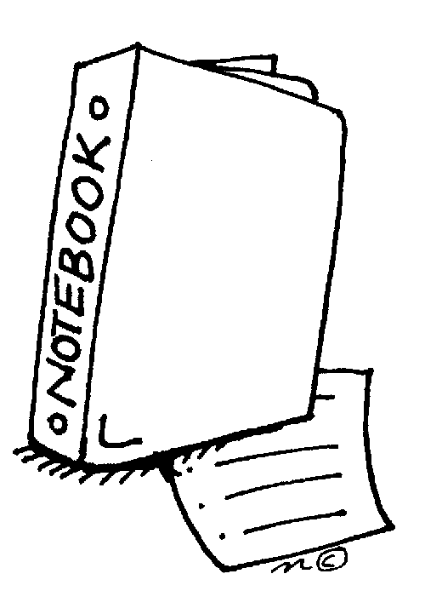48 pre-sharpened Ticonderoga #2 pencils (latex free)
* 1 (12 ct) 7” Crayola pre-sharpened Colored Pencils
* 1 (8 ct) Crayola Washable Thick Classic Markers
* 1 (24 ct) Crayola Crayons
* Pencil Pouch or Container

DO NOT LABEL

* 1 (1”) white view vinyl binder
* 3 (100 ct) Black Marble Composition Book
* 8 pink bevel erasers (latex free)
* 4 Sharpie accent pen style highlighter fluorescent yellow
* 4 Sharpie Black Fine Permanent Marker
* 4 Sharpie Black Ultra-Fine Marker
* 4 Expo thin white board markers
* 1 (2”) White 3- Ring Binder with Clear Front Pocket (for Foreign Language)
* 1 (3”) White 3-Ring Binder with Clear Front Pocket

**ADDITIONALLY**

We are requesting that each student bring a set of headphones to keep at school for his/her personal use. These are not included in our EPI supply orders to ensure each student’s comfort.

**Materials List for Evergreen Academy Elementary School Students 2019-2020**

Please send the following items with your child on September 3rd. These items were selected by the teachers and staff in order to support your child’s learning and educational experiences at each grade level. If you ordered your supply pack through EPI, it will be in the classroom for you. Thank you for your support and for helping us to start off the year successfully!

* Lunch and a healthy snack must be brought to school each day.
* On PE days, your child will need to appropriate footwear for physical activity.
* **To avoid lost items, please label your child’s bag/backpack, coats, and uniforms.**

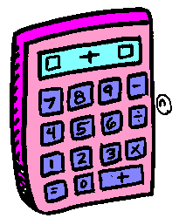**Fourth Grade**

PLEASE LABEL

* 1 school bag/backpack

DO NOT LABEL

* 1 (24 ct) 7” Crayola Pre-sharpened Colored Pencils
* 1 (8 ct) Crayola Markers
* 5 (70 ct) wide rule spiral notebooks (one each red, yellow, blue, green, black)
* 3 packs Ticonderoga pre-sharpened #2 pencils (latex free)
* 24 pencil cap erasers (latex free)
* 3 pink bevel erasers (latex free)
* 2 style highlighters- 1 yellow and 1 color of choice
* 1 Sharpie black ultra- fine point marker
* 1 Sharpie black fine marker
* 4 Elmer’s glue sticks (.77 oz / 22 gram)
* 6 assorted pocket only folders (one each red, yellow, blue, green, black, choice)
* 1 (1”) Vinyl 3-Ring Binder with Clear Front Pocket
* 1 (2”) White 3- Ring Binder with Clear Front Pocket (for Foreign Language)
* 1 (3”) White 3-Ring Binder with Clear Front Pocket
* 3 packs of 3” x 3” colored Post-It Notes
* 1 pair kid-friendly sharp pointed scissors

**ADDITIONALLY**

We are requesting that each student bring a set of on the ear adjustable headphones to keep at school for his/her personal use. These are not included in our EPI supply orders to ensure each student’s comfort.

**Materials List for Evergreen Academy Elementary School Students 2019-2020**

Please send the following items with your child on September 3rd. These items were selected by the teachers and staff in order to support your child’s learning and educational experiences at each grade level. If you ordered your supply pack through EPI, it will be in the classroom for you. Thank you for your support and for helping us to start off the year successfully!

* Lunch and a healthy snack must be brought to school each day.
* On PE days, your child will need to appropriate footwear for physical activity.
* **To avoid lost items, please label your child’s bag/backpack, coats, water bottles and uniforms.**

**Fifth Grade**

PLEASE LABEL

* 1 school bag/backpack
* 1 reusable water bottle
* 1 pencil bag, no holes (at least 11 in x 7.25 in)

DO NOT LABEL

* 4 Elmer’s glue sticks (.77 oz / 22 gram)
* 1 (2”) White Vinyl 3-Ring Binder with Clear Front Pocket (Foreign Language)
* 1 (3”) White 3-Ring Binder with Clear Front Pocket (Portfolio)
* 1 (24 ct) 7” Crayola pre-sharpened Colored Pencils
* 1 box (8ct) Crayola washable broad tip markers
* 1 box (8ct) Crayola washable fine tip markers
* 2 (70 ct) wide rule spiral notebooks (red and blue)
* 1 (120 ct) wide rule spiral 3 subject notebook (any color)
* 1 (100ct) black marble composition book, wide rule
* 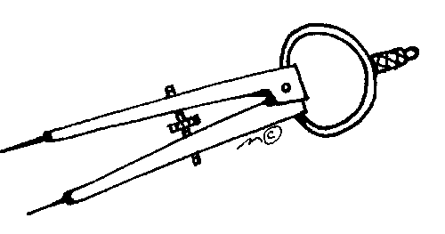6 assorted pocket only folders (one each red, yellow, blue, green, black, choice)
* 2 pink Bevel erasers (latex free)
* 72 Ticonderoga pre-sharpened #2 pencils (latex free)
* 1 style highlighter yellow
* 1 Sharpie black ultra-fine point marker
* 1 Sharpie black fine marker
* 1 pack of 3” x 3” colored Post-It Notes
* 1 pair adult-sized sharp pointed scissors
* 1 manual pencil sharpener (for pencils and colored pencils)
* 6 Black gel pens

**ADDITIONALLY**

We are requesting that each student bring a set of headphones to keep at school for his/her personal use. These are not included in our EPI supply orders to ensure each student’s comfort.