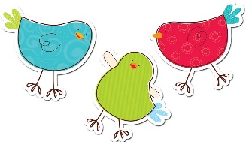
Mrs. Allen’s Kindergarten Schedule
2019-2020
 | Monday | Tuesday | Wednesday | Thursday | Friday
8:30 | Launch | Number Corner & Math | Number Corner & Math | Number Corner & Math | Number Corner & Math
 | Math
9:30 | Snack | Snack | Snack | Snack | Snack
9:45 | Recess | Recess | Recess | Recess | Recess
10:00 | Literacy | Literacy | Literacy | Literacy | Literacy
11:00 | Lunch | Lunch | Lunch | Lunch | Lunch
11:30 | Recess | Recess | Recess | Recess | Recess
12:00 | Social Studies/  Science | Art | Social Studies/ Science | Art | Technology
12:30 |  | Library |  | PE | PE
1:00 | Performing Arts | Literacy | Performing  Arts | Literacy | Literacy
1:30 | Snack | Snack | Snack | Snack | Snack
1:45 | Recess | Recess | Recess | Recess | Recess
2:00 | Literacy | Social Studies/ Science | Literacy | Social Studies/ Science | Social Studies/ Science
2:30 | Foreign Language |  | Foreign Language
3:00 3:10 | Closing & Dismissal (3:10) | Closing & Dismissal (3:10) | Closing & Dismissal (3:10) | Closing & Dismissal (3:10) | Closing & Dismissal (3:10)

