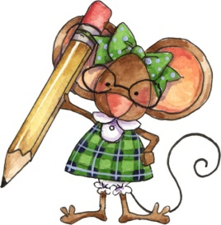
Mrs. Allen’s Classroom Schedule 2021-2022
 | Monday | Tuesday | Wednesday | Thursday | Friday
8:10-8:20 | Morning Car Line | Morning Car Line | Morning Car Line | Morning Car Line | Morning Car Line
8:10-8:30 | Morning Work Time | Morning Work Time | Morning Work Time | Morning Work Time | Morning Work Time
8:30 | Launch (every other Mon.) | Math | Math | Math | Math
8:45 | Math
9:30 | Snack | Snack | Snack | Snack | Snack
9:45 | Recess | Recess | Recess | Recess | Recess
10:00 | Literacy | Literacy | Literacy | Literacy | Literacy
11:00 | Lunch | Lunch | Lunch | Lunch | Lunch
11:30 | Recess | Recess | Recess | Recess | Recess
12:00 | Storytime & Individual Reading | Storytime & Individual Reading | Storytime & Individual Reading | Storytime & Individual Reading | Storytime & Individual Reading
12:30 | Art | Foreign Language | PE | Foreign Language | Performing Arts
1:00 | Performing Arts | Library | Art | Technology | PE
1:30 | Snack | Snack | Snack | Snack | Snack
1:45 | Recess | Recess | Recess | Recess | Recess
2:00 | Social Studies or Science | Social Studies or Science | Fr Social Studies or Science | Social Studies or Science | Social Studies or Science
2:30 |  |  | Handwriting | Handwriting
3:10-3:20 | Afternoon Car Line | Afternoon Car Line | Afternoon Car Line | Afternoon Car Line | Afternoon Car Line

